**Project 1: Canteen Ordering System for Unilever**

**By – Jenifer Pushparaj**

**Stakeholders:**

|  |  |
| --- | --- |
| **ACTOR** | **What they can do on the software created** |
| Employee/Customer | * Employees are so busy with work it is difficult for them to go to the canteen and eat. So, they get options to eat at their workstation while working. * They would order the food from a variety of cuisines. The food should be nutritious and freshly cooked. Where the ordered food is hot and is   served at the right time. |
| Canteen Manager | * They can take out a combined list of all the orders, which are sorted out with sub totals of same dishes people have ordered. For example, chicken and sauce - 40, Rice with kidney beans - 40 etc. * The system should also give a floor wise list of orders to plan deliveries. * Data and reports on most ordered items, least ordered items with quantities for planning the inventory. |
| Delivery Boy | * He should have a list with floor wise open orders. After food is delivered, he will checkbox the items on his list. After delivering all the orders he will close the orders on the software. * A tablet can also be used for closing orders as and when they get delivered. |
| Payroll system | * list of employees with total Price of food items ordered on working days. * Employee wise list of items ordered and price (date wise) which gets appended with salary statement for employees to check deduction. |
| Management | * Most ordered and least ordered items with various drilldowns such as floor wise, department wise which can be used for forecasting. * List of employees enrolled and no of orders placed. |

**Problem Definition and Solution**

In its UK offices, Unilever had around 1500 employees which were spread across 12 floors. They had 2 canteens to cater to these 1500 employees. Each canteen could seat around 150 employees at a time. Most employees would prefer to take their lunch between 12 noon to 1 pm. This led to a huge rush in the canteen during lunch hours resulting in employees wasting a lot of time waiting for tables to be vacant. Management calculated that it took around 60 minutes for employees to go and come back from lunch. Almost 30-35 minutes were wasted waiting in a queue to collect their food and get a table to sit and eat. However, the time spent eating was barely 10-15 minutes.

**Solution:** Employees have requested a system that would permit a canteen user to order meals online, to be delivered to their work location at a specified time and date.

**Advantages and Objectives**

Advantages of the Canteen Ordering System:

* A system would save considerable time to those employees who use the service.
* It would increase the chance of them getting the food items they prefer.
* This would improve both their quality of work life and their productivity.
* The food wastage will be reduced.
* This will reduce the cost.

**Objectives:**

No: of Employees = 1500

Hours used (Collectively by 1500) = 60 min = 1 hr

Hours used in month = 1hr x 26 days = 26 hours per month

Increase worktime average in future = 30min per day

Collective employee lunch time reduction = 1 – 0.5 = 0.5 min = 30 min

Productivity increase per month = 26 hrs – (0.5hr x 26 days) = 13 hours per month

**Solution:** Approximation and logic used shows an approximate 13hrs extra productive worktime is achievable in a month which can be optimized and improved in later stages for the company.

**Existing System**

* Employees don’t always get their choice of food they want because the canteen runs out of certain items.
* The canteen wastes a significant quantity of food by throwing away what is not purchased.

**Proposed System**

The System that would permit a canteen user to order meals online, to be delivered to their work location at a specified time and date.

* User friendly interface.
* Work time will be efficient.
* Employee have the choice of food.
* Food wastage will be reduced.

**Scope using *use case diagram* (UML)**

Create a use case diagram including all the actors and processes for an end to end process of the system.

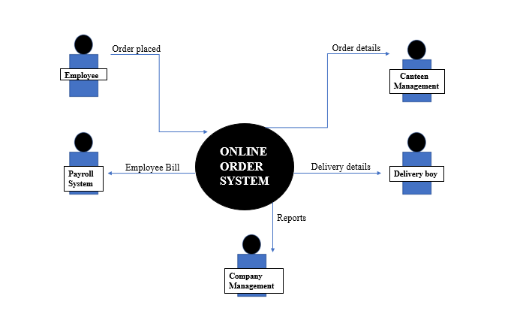

**Scope using *context diagram***

Depict the scope using Context diagram.

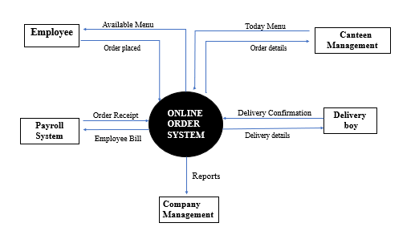

**In Scope**

* Order forecasting – Employees order will be forecast to the chef. It helps the chef to cook the food in the meantime.
* Reduce wastage – By reducing the wastage of food, the cost spent has been lowered.
* Software – It is the main source for the actors to collect the data.
* Worktime – By this method we improve the working hours of the employee to obtain efficient work.

**Out of Scope**

* Free space utilization
* Delivery boy selection

**Activity Diagram for the System:**

Create an activity diagram for the system.



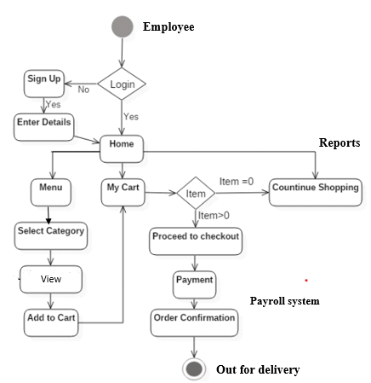

**ER Diagram for the System:**

Create an ER Diagram for the system you have designed.

**Payroll System**

**Employee Directory**

**Procedure**

* ID
* Floor number
* Name
* Designation
* Employee salary
* Agreement form for canteen bill

**Order Requests**

**Menu**

* Special request
* Time
* Location

Days menu

**Agreement Authorisation**

**Kitchen**

* Chef acknowledgement
* Order processing time

**Delivery**

**Process**

* Order details
* Employ Details

**Report**

* Resource usage
* Menu preference

**Business Requirements:**

**Business objective – 1:** Reduce canteen food wastage by a minimum of 30% within 6 months following the first release.

Scale: Value of food thrown away each month by examining the canteen inventory.

• Previous – 25% wasted.

• Must plan for: Less than 15%.

**Business objective – 2:** Reduce canteen operating costs by 15% within 12 months, following the initial release.

**Business objective - 3:** Increase average effective work time by 30 minutes per employee per day, within 3 months.

**Business objective - 4:** By making the ordering process automated and by delivering the food to the user's workstation, the canteen will be able to operate with lesser manpower.

**Functional Requirements**

* Users should be able to create accounts, logon and have password recovery.
* An administrator should be able to assign roles to a User, which reflects
* their position. e.g. Canteen Manager, Delivery Boy, Management, User
* (Employee/Customer)
* Salary deduction acceptance to act as login and employee uses his existing company credentials to login. Employee ID and Workstation Details as login details.

Roles should have access only to respective modules:

* Canteen Manager Role - Create a variety of lists of Orders including for Delivery Boy
* User Role – Select a Menu and place an order. Provide feedback on the order, View past orders, accept/deselect salary deduction option
* Delivery Boy Role – View a list of Orders as defined by the Canteen Manager.
* Update an order to indicate delivered.

**Non-functional Requirements**

**System Requirement:**

* Data should be stored in cloud.
* The system should also give a floor wise list of orders to plan deliveries.
* Order Transactions or feedback should be traceable.

**Usability:**

* active internet connection is needed to use the software.
* User friendly and user interface.
* All employee can browse but only those who accept payroll deduction will be allowed to order.

**Environments**

* Employees can avoid ques and moving time.
* Order what they want.
* Increase worktime and productivity
* Decrease food wastage.
* Decrease in canteen operational cost.
* Formulate food preparation patterns and improve quality by feedback

**Prototype:**



Click here

We deliver your order on time…

**Search…**

**NOW ORDER YOUR FAVOURITES.**

**FRESH JUICE,**

**FRESH FOOD,**

**FRESH SNACKS etc.**

**PAYROLL PAYMENT**

**MENU**

**MY CART**

**MY ACCOUNT**

**SIGN IN**

**Unilever Canteen Ordering System**